
Irrigation: From Conventional to Contemporary Techniques
3rd International Conference on Recent Academic Studies
December 03-04, 2024 : Konya, Turkey
© 2024 Published by All Sciences Academy
https://as-proceeding.com/index.php/icras
Rafika Helaimia
Rakahelaimia@yahoo.fr

Abstract – Agriculture stands as the predominant consumer of water, accounting for nearly 70% of global freshwater withdrawals. Numerous regions worldwide are grappling with water scarcity, which has resulted in a heightened demand for food to support a growing population. This scenario underscores the urgent need for innovative strategies that can improve water efficiency while safeguarding food security. To effectively monitor and adapt agricultural practices in response to these challenges, it is crucial to integrate new technologies aimed at enhancing productivity and sustainability. Among these innovations, smart irrigation has emerged as a contemporary solution that is increasingly recognized for its potential to improve agricultural practices. Smart irrigation systems utilize advanced sensors, weather data, and automated controls to deliver water precisely when and where it is needed, thereby minimizing waste and maximizing efficiency. This study explores a variety of irrigation techniques, ranging from traditional methods to the latest advancements in the field. Traditional irrigation practices, such as flood and furrow irrigation, have been the cornerstone of agricultural water management for centuries. While these methods have been optimized in certain situations, they often do not measure up to modern alternatives. Contemporary irrigation techniques, such as drip irrigation and sprinkler systems, provide more efficient solutions.
Keywords – Irrigation, types, convenetional, Modern, challenges, suggestions
- INTRODUCTION
In the 21st century, humanity is grappling with two monumental challenges that threaten food security and environmental sustainability: the escalating demand for food and water, driven by unsustainable agricultural practices, and the urgent need to accommodate a rapidly growing global population. This situation is exacerbated by climate change, which alters weather patterns and affects crop production, further complicating efforts to ensure a stable food supply. Irrigation has long been recognized as a vital component in enhancing agricultural productivity, allowing farmers to cultivate crops in regions with insufficient rainfall. However, traditional irrigation methods, such as flood irrigation, have led to significant environmental repercussions. These practices often result in severe water wastage, as large volumes of water are lost to evaporation and runoff. Additionally, the over-extraction of water from rivers and aquifers has led to land degradation, soil salinization, and the depletion of vital water resources. Consequently, these unsustainable practices have diminished crop yields, making it increasingly difficult to meet the growing global agricultural demands. In response to these challenges, the integration of the Internet of Things (IoT) into various sectors, including agriculture, has emerged as a transformative solution. One of the most promising applications of IoT in agriculture is smart irrigation. Smart irrigation systems utilize sensors, weather data, and soil moisture levels to optimize water usage, ensuring that crops receive the precise amount of water they need for healthy growth. By automating irrigation processes and reducing reliance on traditional methods, smart irrigation has demonstrated remarkable effectiveness in conserving water resources. Studies have shown that these systems can reduce water consumption by up to 50% while

1071

simultaneously enhancing crop yields. the integration of IoT technologies into agriculture presents a promising pathway toward sustainable farming.

- Definition of Irrigation
Irrigation refers to the artificial application of water to crops, a practice that has been developed and refined by humans over thousands of years. This technique is particularly essential in arid, semi-arid, and sub-humid regions, suffering from lack of natural rainfall to meet the water needs of crops. Additionally, irrigation is crucial in areas experiencing uneven water distribution, where some regions may receive excessive rainfall while others suffer from drought. It is also beneficial in soils with low water retention capacity, in which the growth of the crops is hindered by evaporation and lack of moisture.
The establishment of effective irrigation systems enables these regions to considerably lessen their dependence on expensive agricultural inputs, such as fertilizers, pest management strategies, and specially chosen crops . The availability of irrigated land will increase crop yields and productivity across various types of crops, thereby enhancing the livelihoods of farmers, communities, and economically developed nations.
Moreover, the advancement of irrigation technology presents an opportunity to transition from traditional methods, which may be less efficient and more labor-intensive, to more modern and sophisticated practices. Techniques such as drip irrigation, sprinkler systems, and automated irrigation management can optimize water usage, minimize waste, and reduce the environmental impact of agricultural practices. These innovations can lead to more sustainable farming practices, allowing for the conservation of water resources while still meeting the demands of growing populations.
In addition to improving agricultural productivity, effective irrigation practices can also play a vital role in enhancing soil health and fertility. By maintaining optimal moisture levels, irrigation can help prevent soil erosion, promote the growth of beneficial microorganisms, and improve nutrient availability. This holistic approach to water management not only benefits individual farmers but also contributes to the resilience of entire agricultural systems in the face of climate change and other environmental challenges.
- Types of Irrigation
Irrigating the land can be implemented throug two types of irrigation: Traditional conventional mehtods and Modern or smart methods.
  - Traditional methods
Tradational methods of irrigation are based on the use of hand-made tools like cannals to transport water from natural sources such as rivers to the agricultural lands. There four types are:

  - Check Basin Method

This method, aptly named, revolves around the strategic use of multiple basins strategically positioned throughout agricultural fields to facilitate the irrigation of large expanses of land. The approach is not only practical but also highly effective, as it allows for the efficient distribution of water resources across vast areas, ensuring that crops are idealy grown due to the amount of sufficiently hydration water quantity, the protection of the soil the environment from the erosion issues, increasing the rate of soil fertility to overcome salinity and reduce the risk of water runoff.

  - Furrow Irrigation Method

Firrow irrigation, as indicated by its name, involves partitioning the land into multiple rows and distributing water accordingly. This method has demonstrated its effectiveness as a cost-efficient technique that is straightforward to implement and environmentally friendly. It helps safeguard both the land and the environment from various issues, including soil depletion, crop dehydration, water runoff, contamination of natural water sources, and reduced labor costs.

  - Strip Irrigation Method

The strip irrigation method, as its name suggests, is a manual technique applied to strips of land that are divided according to their size. This method has proven to be an effective environmentally sustainable practice that safeguards the soil from erosion, enhancing its mineral richness and resilience. It also prevents crop dehydration by ensuring adequate water absorption, conserves water from waste and contamination, and alleviates the labor burden on farmers.

  - Basin Irrigation Method
This technique involves the strategic irrigation of trees and shrubs utilizing a drainage water source, which can be an effective method for promoting healthy growth and maintaining soil vitality. By harnessing drainage water, which is often rich in nutrients and organic matter, this approach ensures that the trees and shrubs receive a consistent and adequate supply of moisture. As a result, the soil surrounding these plants becomes highly hydrated, allowing it to absorb a substantial volume of water. The significance of conserving water must be mentioned in order to ensure that a large quantity of water is protected from water runoff.

The traditional irrigation techniques referenced above are established methods that have proven their effectiveness in environmental, economic, and social contexts. Nevertheless, if these methods are not managed properly, soil erosion may occur, water resources could be squandered, productivity may decline, and farmers may experience fatigue and frustration.

III.Modern methods of irrigation
Modern irrigation pertains to the application of contemporary technologies aimed at improving the efficiency of water usage, soil management, and crop yield. Among these tools are:

- Drip Irrigation

Drip irrigation, also known as trickle or micro-irrigation, is a contemporary technique that utilizes a plastic pipe ranging from 13 to 32 mm in diameter, which is connected to an irrigation system designed to deliver water directly to the root zone of crops in a drop-by-drop manner, rather than saturating the entire soil area. It is estimated that this system can emit approximately 1 to 8 liters of water per hour, operating under a pressure of 1 to 2.5 kg/cm². Research has demonstrated that this method is both feasible and effective, as it improves crop health and yields, enhances soil nutrient levels, reduces water usage by up to 70%, and promotes environmental sustainability.

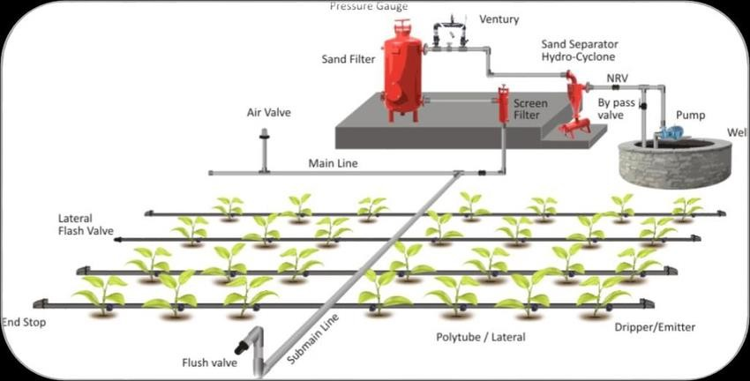
Fig. 1. Drip Irrigation : from group of authors: Optimal Planting Geometry and Growth Stage Based Fertigation in Vegetable Crops

- Sprinkler Irrigation
The sprinkler irrigation system is an advanced agricultural technique designed to mimic the natural process of rainfall, providing a controlled and efficient method of watering crops. This system operates by releasing water from a network of pressurized pipes into the atmosphere, where it is dispersed in the form of droplets. These droplets then fall back to the ground, allowing for uniform distribution across the soil surface. The design of the system ensures that each droplet of water is effectively absorbed by the soil, promoting optimal moisture levels for plant growth while minimizing the risk of structural damage to the soil structure itself.At the heart of the sprinkler irrigation system are several key components that work together to deliver water efficiently. The primary component is the pressurized pipe network, which includes a main line pipe responsible for transporting water from the source—such as a well, reservoir, or municipal supply—to the various sprinkler devices. These devices, which can vary in design and function, are strategically placed throughout agricultural fields to ensure even coverage. One of the most critical advantages is the prevention of soil erosion and water runoff. By distributing water in a controlled manner, the system reduces the likelihood of excess water pooling or flowing away from the intended areas, which can lead to the loss of topsoil and nutrients. Additionally, the uniform application of water helps to maintain soil structure and health, fostering a more conducive environment for root development. Moreover, sprinkler irrigation can lead to improved crop yields. By ensuring that crops receive the right amount of water at the right time, farmers can enhance plant growth and productivity. In addition, the sprinkler irrigation system also plays a vital role in promoting environmental sustainability. By optimizing water usage, this system helps to conserve water resources, which is increasingly important in the face of climate change and growing water scarcity.

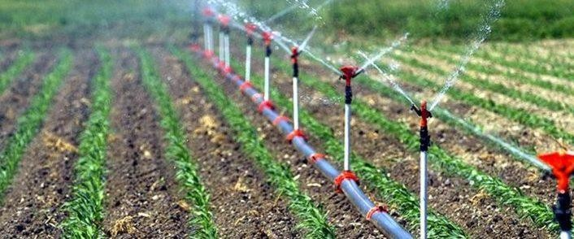

Fig.2. Sprinkler Irrigation: From: https://dekaboru.com/case/sprinkler-irrigation-system/

- Clay Pot Irrigation

Clay/olla pot irrigation, commonly known as pitcher irrigation , is an innovative and sustainable approach to water management that serves as a modern alternative to conventional drip irrigation systems. This technique involves the strategic placement of unglazed clay pots, which are filled with water, directly into the soil where crops are cultivated. The porous nature of the clay allows water to seep slowly and steadily into the surrounding soil, providing a consistent moisture supply to the plant roots.This method is particularly advantageous for small-scale farmers, especially in regions where water scarcity poses a significant challenge. By utilizing clay pots, farmers can optimize their water usage, ensuring that crops receive the necessary hydration without excessive waste. This is especially crucial in arid and semi-arid areas, where traditional irrigation methods may lead to rapid evaporation or runoff, further exacerbating water shortages. In addition to its water-saving benefits, clay pot irrigation also addresses soil degradation issues, such as erosion and nutrient depletion. The slow release of water helps maintain soil structure and moisture levels, promoting healthier root systems and enhancing overall crop resilience. Moreover, the simplicity and low cost of implementing clay pot irrigation make it an accessible option for many farmers, particularly in developing regions. Unlike more complex irrigation systems that require significant investment and technical expertise, clay pot irrigation can be easily adopted.
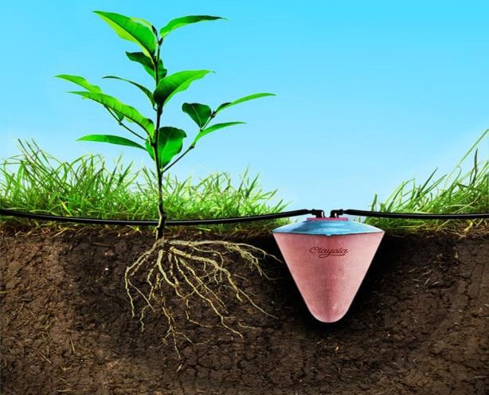

Fig.3. Clay pot Irrigation. From: https://www.urbangardensweb.com/2017/07/24/egyptian-clay-pots-water-plants-month/

Recent advancements have led to the development of innovative techniques for the efficient application of smart irrigation systems, which are regarded as state-of-the-art technologies aimed at improving irrigation practices, particularly in minimizing water runoff. Notable examples include smart irrigation controllers and smart irrigation sensors.
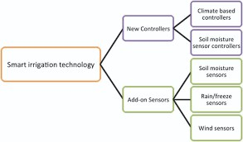

Fg.4. Sensors and Controllers Controling Irrigation

- Smart Irrgation Controllers
Smart irrigation controllers are devices equipped with water-saving functionalities designed to assess the irrigation requirements of a landscape. These controllers can be categorized into two types: climate-based controllers and moisture-based controllers.

- Climate Based Controllers
The climate-based irrigation system known as evapotranspiration represents a significant advancement in agricultural and landscape management technology. This sophisticated system is designed to optimize water usage by integrating various modern irrigation techniques, allowing for a more efficient and sustainable approach to watering plants. By collecting and analyzing critical data related to weather conditions, soil moisture levels, and the specific needs of different plant species, the system effectively prevents both the overuse and underuse of precious water resources.Evapotranspiration, which refers to the combined processes of evaporation from the soil and transpiration from plants, serves as a key metric in determining the appropriate amount of water required for optimal plant growth. This system can be implemented across a wide range of landscapes, whether utilizing traditional sprinkler systems or more targeted drip irrigation methods. The installation process typically involves laying down a network of pipes and setting up an irrigation timer that controls electric valves. These valves are programmed to open and close according to pre-established schedules, which can be adjusted based on real-time data inputs.One of the standout features of climate-based irrigation controllers is their ability to collect local weather data, including temperature, humidity, wind speed, and rainfall. By continuously monitoring these environmental factors, the system can make real-time adjustments to irrigation schedules. For instance, if rain is forecasted, the system can delay or reduce watering, ensuring that the landscape receives only the necessary amount of water. Conversely, during periods of high heat or drought, the system can increase watering frequency to meet the plants' needs.

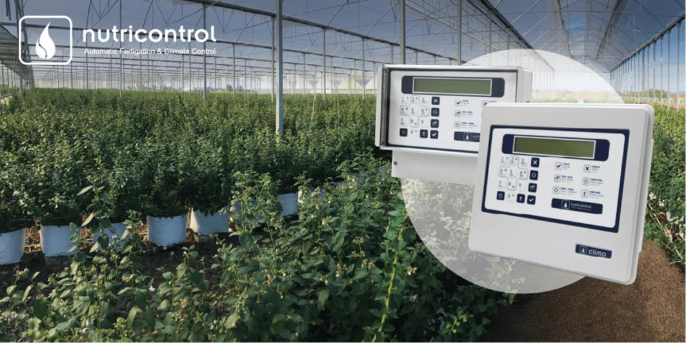

Fig.5. Climate Based Controllers Machine . From: https://nutricontrol.com/en/benefits-of-climate-control-automation/

- Moisture-Based Controllers.

Soil moisture sensors are sophisticated devices designed to be installed in the ground, where they play a crucial role in assessing the moisture levels and water content of the soil. These instruments are essential for understanding the hydration status of the soil, which directly impacts plant health and agricultural productivity. By measuring the moisture content, these sensors provide valuable insights that can help farmers, gardeners, and researchers make informed decisions regarding irrigation and soil management. The operation of soil moisture sensors involves converting soil temperature readings into actionable data about both the soil and the plants that depend on it. This conversion process allows users to gain a deeper understanding of the soil's moisture dynamics, which is vital for optimizing water usage and ensuring that plants receive the right amount of hydration. The sensors can be designed to be either fixed in place, providing continuous monitoring of a specific location, or easily transportable, allowing users to move them to different areas as needed for varied assessments. There are two primary categories of soil moisture sensors: those that measure volumetric water content and those that gauge soil tension. Volumetric water content sensors provide a direct measurement of the amount of water present in the soil, expressed as a percentage of the total soil volume. This information is crucial for determining whether the soil is adequately moist for plant growth or if irrigation is necessary. On the other hand, soil tension sensors measure the force with which water is held in the soil, indicating how difficult it is for plants to extract moisture. This tension measurement can help users understand the availability of water to plants and guide irrigation practices accordingly. In addition to their measurement capabilities, many modern soil moisture sensors come equipped with advanced features that enhance their functionality. For instance, these sensors can be configured to activate irrigation systems automatically when the volumetric water content falls below a predetermined threshold set by the user. This automation not only saves time and labor but also ensures that plants receive consistent and timely watering, which is essential for maintaining optimal growth conditions. By integrating soil moisture sensors with irrigation systems, users can achieve more efficient water management, reduce waste, and promote sustainable agricultural practices.

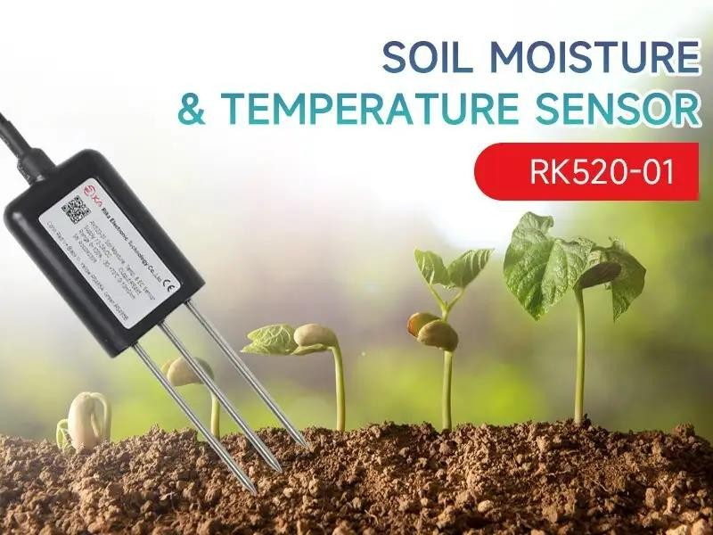

Fg.6. Moisture-based Controller. Fromom: https://www.rikasensor.com/blog-enhancing-agricultural-and-environmental- monitoring-with-soil-moisture-and-temperature-sensors.html
IV.Challenges and Solutions of Smart Irrigation
Smart irrigation presents both challenges and solutions in its implementation. While it has proven to be highly effective in conserving water, improving crop yields, protecting soil from erosion, and contributing to a more sustainable environment, it remains a topic of ongoing debate due to certain adverse effects associated with its use.
Firstly, the high cost of smart irrigation systems often makes them inaccessible for small-scale farmers. These farmers, who play a crucial role in global food production, may struggle to invest in advanced technologies that could significantly enhance their agricultural practices. This issue could be addressed through partnerships with companies in developed nations, which could facilitate access to this technology. By providing financial assistance, subsidies, or even leasing options, these partnerships could empower small-scale farmers to adopt smart irrigation systems, ultimately leading to improved agricultural productivity and sustainability.
Secondly, some smart irrigation devices may not adequately protect the environment, particularly in preventing soil erosion. While these systems are designed to optimize water usage, they can inadvertently contribute to erosion if not properly calibrated or managed. This challenge can be overcome by utilizing more advanced machinery designed to optimize water usage while also incorporating features that monitor and protect soil integrity. For instance, integrating sensors that detect soil moisture levels and erosion risks can help farmers make informed decisions about irrigation practices, thereby minimizing environmental impact.
Thirdly, the application of smart irrigation is not universally suitable for all soil types, as some soils are better suited to traditional irrigation methods. For example, sandy soils may require different irrigation strategies compared to clay soils, which retain water more effectively. However, this limitation can be alleviated by enriching less fertile soils with essential nutrients and organic matter. By improving soil health through practices such as cover cropping, composting, and crop rotation, farmers can enhance the effectiveness of smart irrigation systems, making them more adaptable to various soil conditions.
Lastly, the operation of smart irrigation systems typically requires significant energy consumption, raising concerns about their overall sustainability. This concern can be mitigated by integrating renewable and sustainable energy sources into their functionality. For instance, solar panels can be installed to power irrigation systems, reducing reliance on fossil fuels and lowering operational costs. Additionally, the use of

energy-efficient technologies and practices can further decrease energy consumption, making smart irrigation a more environmentally friendly option.
V Conclusion
This research underscores the significance of adopting smart irrigation practices due to the myriad advantages they offer to various stakeholders, including individual farmers, local communities, crops, soil health, and the overall ecosystem. By implementing advanced irrigation techniques, farmers can optimize water usage, leading to increased crop yields and reduced operational costs. This not only enhances the economic viability of agricultural practices but also contributes to the sustainability of water resources, which is crucial in the face of climate change and growing water scarcity.Moreover, smart irrigation practices promote healthier soil by preventing overwatering and minimizing soil erosion, which can degrade land quality over time. Healthier soil, in turn, supports robust plant growth and fosters biodiversity, creating a more resilient agricultural ecosystem. The positive ripple effects extend beyond individual farms, benefiting entire communities by ensuring food security and promoting environmental stewardship. Given these compelling benefits, this study encourages researchers to broaden the scope of inquiry in the fields of irrigation and agriculture. Future investigations and interdisciplinary research in this area, can pave the way for more resilient agricultural systems that are better equipped to meet the challenges of the future.
Acknowledgement
I wish to express my gratitude to the organizers of the conference for providing me with the opportunity to participate. Additionally, I would like to extend my thanks to the reviewers and encourage the organization of future conferences to broaden the scope of research.
References
- Tony ware, The most Modern Methods of Irrigation, https://www.twl-irrigation.com/modern-methods-of-irrigation, 13th December,2023.
- Malarie Gotcher, Saleh Taghvaeian, Justin Quetone Moss, Smart Irrigation Technolog: controllers and Sensors, https://extension.okstate.edu/fact-sheets/smart-irrigation-technology-controllers-and-sensors.html. Feb.2017
- https://extension.umn.edu/irrigation/soil-moisture-sensors-irrigation-scheduling#pros%2C-cons-and-costs-of- volumetric-water-content-sensors-1751860 accessed on09/11/2024
- https://www.niubol.com/Product-knowledge/What-Soil-Moisture-Sensor.html accessed
- on09/11/2024
- https://www.rikasensor.com/blog-enhancing-agricultural-and-environmental-monitoring-with-soil-moisture-and- temperature-sensors.html accessed on 19/11/2024
- S M Pandey, Ambrish Maurya, Chetan Kumar, Hirwani Om Ji Shukla, Challenges and Opportunities in Industrial and Mechanical Engineering: A Progressive Research Outlook, Proceedings of the International Conference on Progressive Research in Industrial & Mechanical Engineering (Prime 2021), August 05–07, 2021, Patna, India.
- V. Aravind Babu, Mr. P. Manikanta, Mr. T. Vamsi, Mr. M. Sai Anurag, AUTOMATED POT IRRIGATION AND IOT BASED MONITORING SYSTEM, DEPARTMENT OF ELECTRONICS AND COMMUNICATION ENGINEERING ANIL NEERUKONDA INSTITUTE OF TECHNOLOGY AND SCIENCES (UGC AUTONOMOUS),2023-2024.
- Barsha Mansingh,Rahul Banik, Subrata Bag, Aakash Sunaratiya, Drip Irrigation System: An Effective Approach for Increasing Water Use Efficiency, BIOTECH BOOKS,2023.
- Bohra , Deepti Bisht Bohra , Salil K. Tewari, Drip Irrigation System: A Water and Nutrient Conservation Approach to Sustainable Crop Production, International Journal of Environmental & Agriculture Research (IJOEAR) ISSN:[2454- 1850] [Vol-8, Issue-11, November- 2022]
- Janani M. ,Jebakumar R. A Study on Smart Irrigation Using Machine Learning, A Study on Smart Irrigation Using Machine Learning,2019.
- Sairam Arpula, Banoth Bixapathi Nayak, Karupakula Shirisha, Smart Irrigation Systems in Agriculture, Kripa-Drishti Publications, Pune,2024.
- Amir el Ghamry, Smart irrigation system using IoT and machine learning methods , Proceedings of NILES2023: 5th Novel Intelligent and Leading Emerging Sciences Conference,2023.

- Yomna. Gamal , Ahmed Soltan , Lobna A. Said, Ahmed H. Madian, Ahmed G.Radwan, Smart Irrigation Systems: Overview, IEEE Acess journal,2023.
- Malarie Gotcher,te Saleh Taghvaeian, Justin Quetone Moss, Smart Irrigation Technology: Controllers and Sensors, Division of Agricultural Sciences and Natural Resources • Oklahoma State University,2010.
- JUAN ANTONIO RODRÍGUEZ DÍAZ, CONCEPTS OF SPRINKLER IRRIGATION: TYPES, DESIGN, ASSESSMENT, IMPLEMENTATION AND OPERATION, UNIVERSITY OF CORDOBA, ONLINE ADMINISTERED COURSE – 16 DECEMBER 2020.
- Derrel L. Marti,Dennis C. Kincaid, William M. Lyle, DESIGN AND OPERATION OF SPRINKLER SYSTEMS, chapter 16, DOI: 10.13031/2013.23699,Source OAI, January 2007

